**Take Home Program #7 – Due on or before Tuesday 4/23, 2019 –**

**Objectives:** Functions – Call by References

Your name:

|  |
| --- |
| **Important instructions:**   * *All programs must include comments at the top of your program: your name,* the class name (CSIT 575)*, program name and* ***the program description (purpose of the program).*** * *Copy and paste your* ***program code*** *and* ***output*** *in Part B of each program. Note: Use snipping tool to* ***snip the output****.* * *Once it is done, save and submit this word file via Canvas.* |

**RandomLetters.cpp**

Write a program to generate a random letter and writes random uppercase letters to the screen based on ASCII chart (A = 65 and Z = 90).

The program must include the following function prototypes:

* **void WriteHeader()** // type 1: Display program introduction
* void **AskNumberToDisplay(int&)** // function pass by references – Ask a user to enter the number of characters being display.
* **void CountingDisplay(int)** // type 2: counting the number of characters being displayed; this functions calls GenerateLetter function.
* **char GenerateLetter()** // type 3: Generates alpha letters using random function.

**Sample run:**

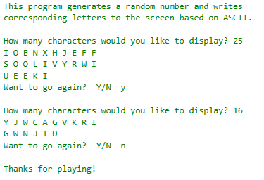

**Part B: Copy and paste your program (source) code and the outputs after this line**

**+++++++++++++++++++++++++++++++++++++++++++++++++**